**5 Centimeters Per Second**

Animation/Drama, 2007

**JAPANESE FILM NIGHT - TEATAR KABARE TUZLA – APRIL 24, 2012 - 18:00 - FREE ENTRANCE**

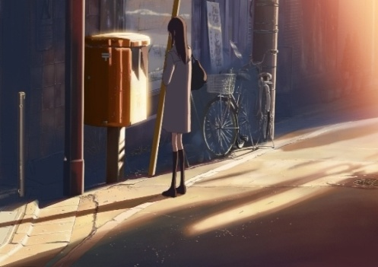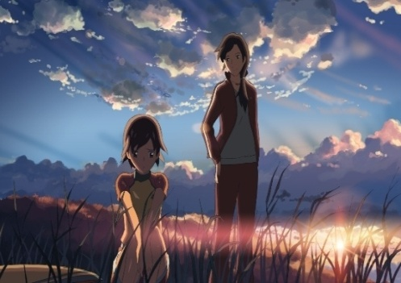

|  |
| --- |
| After being transferred to the same elementary school, Takaki and Akari become best friends. However, when their families are forced to relocate, their lives change. Takaki and Akari wonder if they will ever be able to see each other again, and share their secret feelings. After a year of separation, Takaki is about to reunite with Akari. Riding the train from Tokyo, memories of past rush through his mind as the meeting draws closer…  Join Akaki on a journey through three interconnected tales of love and lost innocence.  The title, 5 Centimeter Per Second, refers to the speed at which cherry blossom fall from a tree, signifying the evanescent nature of life, and how often people drift away from each other. As the film director says, even though our real lives are tainted by sad and dramatic events, the world still brightens our lives with its beauty and colorful events that make life worth living…  **Director & Screenplay**: Makoto SHINKAI  In 2000, SHINKAI directed animation *She and Her Cat,* followed by *The Vocies of a Distant Star* in 2002, which won several awards including the Special Achievement Award at the Japan Media Arts Festival. *The Place Promised in Our Early Day (2004s*, Shinkai’s first directorial feature film animation including references to some literary works and themes such as separation and dreams, won the Best Animation Feature Film Award at the Seoul Int’l Cartoon and Animation Festival.  **Cast**: Kenji Mizuhashi, Yoshimi Kondo, Satomi Hanamura, Ayaka Onoue  FILM IS SHOWN WITH ENGLISH SUBTITLES |

**Happy Flight**

Comedy, 2008

**JAPANESE FILM NIGHT - TEATAR KABARE TUZLA – APRIL 24, 2012 - 19:30 - FREE ENTRANCE**



|  |
| --- |
| Shinobu Yaguchi brought feelings of laughter, tears, and exhilaration to audiences in Japan with his films about boys' synchronized swimming and girls' high school big band jazz. The theme of his latest film is "airplanes" of all things! Usually, films featuring airplanes tend to be panic films or focus on just the pilots and flight attendants. But Yaguchi's intent was to create a more realistic, completely new film that oversees all corners of the aviation industry. He interviewed the various sections to create his story, to understand just how many people are involved in making a single airplane take off and land. The setting of the film is an airport and airplanes. A great variety of "aviation professionals" such as pilots, flight attendants, the ground crew, mechanics, dispatchers, controllers, and the bird patrol crew all support a single flight. They have only one mission: to secure the safety of the passengers!  Today was supposed to be any other day on the job, departing on schedule and heading safely to Honolulu, but…  The experience of watching this film is fun and exciting, just like actually riding on a jumbo jet. A wonderfully entertaining film about the aviation industry chock-full of Shinobu Yaguchi's love and fascination towards airplanes has been born!  **Director & Screenplay**: Shinobu YAGUCHI  Yaguchi’s work *The Rain Women* (8mm) won the Grand Prize in PFF Award Competition 1990. He made his feature film debut with the 7th PFF Scholarship film *Down the Drain* ('93). Since then, he has constantly released many works that feature his unique sense of humor. *Water Boys* ('01) is a shining example of Yaguchi's style, and he is one of the most noteworthy filmmakers in the industry today.  **Cast:** Seiichi Tanabe, Saburo Tokito, Haruka Ayase, Kazue Fukiishi  FILM IS SHOWN WITH ENGLISH SUBTITLES |